SQL PURCHASE BEHAVIOUR ANALYSIS
DATASET: Predict Customer Purchase Behaviour Dataset (Kaggle)
VARIABLES:
- Age: Customer's age
- Gender: Customer's gender (0: Male, 1: Female)
- Annual Income: Annual income of the customer in dollars
- Number of Purchases: Total number of purchases made by the customer
- Product Category: Category of the purchased product (0: Electronics, 1: Clothing, 2: Home Goods, 3: Beauty, 4: Sports)
- Time Spent on Website: Time spent by the customer on the website in minutes
- Loyalty Program: Whether the customer is a member of the loyalty program (0: No, 1: Yes)
- Discounts Availed: Number of discounts availed by the customer (range: 0-5)

QUERY 1: Identifying which age demographic transacts the most

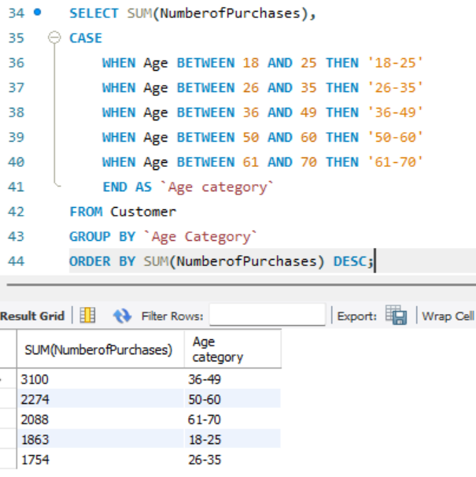

- Thus, we can see that the maximum number of purchases have been done by the age category of 36-49, beating out the second most (50-60) by almost 1000 more purchases
- We can infer that the key demographic making purchases in this store is in the middle-aged group, followed by senior citizens, whereas the younger 2 categories (18-25 and 26-35) make the least number of purchases.

QUERY 2: In the 36-49 age category, which product categories are the most popular

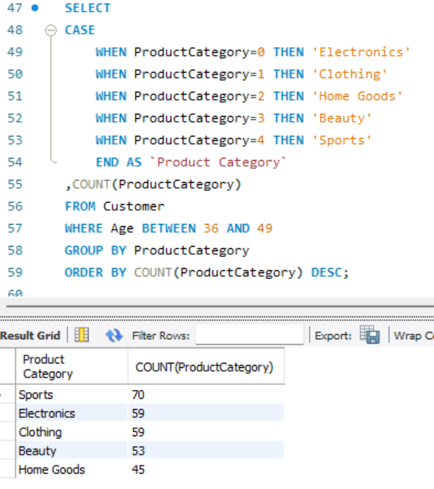
- In the age group that makes the most purchases (36-49), we can then analyse which product categories are the most popular among them. We find that to be sports and electronics, with the least number of purchases for home goods.
- A possible inference we can make here is as individuals settle into their jobs, and attain a steady flow of income, their expenditure shifts towards recreational goods, whereas daily necessities (demand for which is relatively inelastic) consumes less of their income

Query 3: Comparing Number of purchases within a category to average purchases in that category, using window function

Query 4: Identifying top spenders in each category using CTE and dense_rank() window function
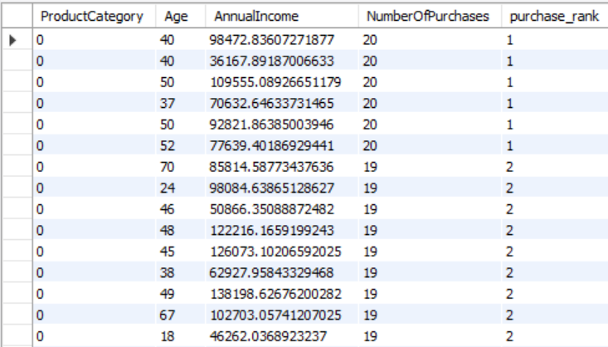
- We can identify the characteristics of individuals who make the most purchases in a respective category
- This helps us formulate targeted advertisements or sales strategies

Query 5: Checking correlation between time spent on site and no of purchases, to determine how strong the intent to make a purchase was when logging into the site

